SQL101 Assignment

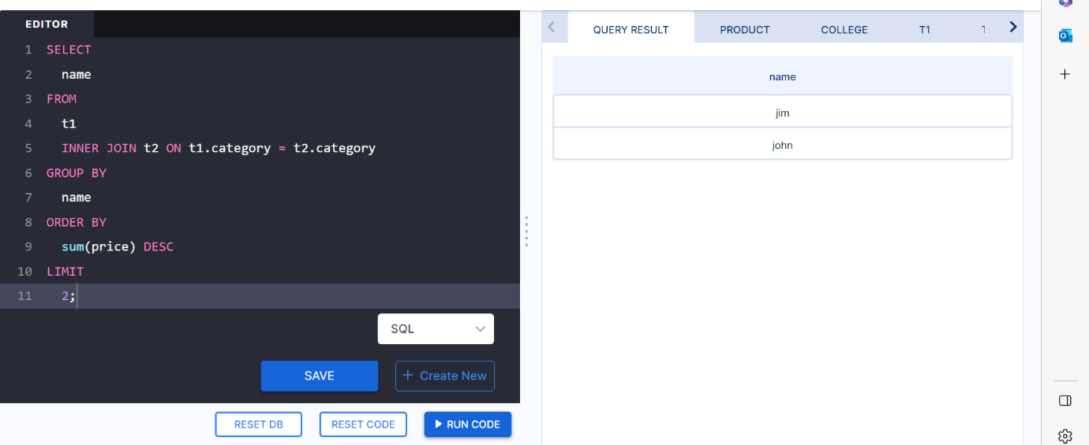**1.Name the top 2 customers who has highest transactions**

SELECT

name

FROM

t1

INNER JOIN t2 ON t1.category = t2.category

GROUP BY

name

ORDER BY

sum(price) DESC

LIMIT

2;

**2.Name the category whose prices are not listed**

SELECT

t1.category

FROM

t1

LEFT JOIN t2 ON t1.category = t2.category

WHERE

t2.price IS NULL

GROUP BY

t1.category;

**3.Provide the names of the cities in descending order based on the sum of transactions that have occurred.**

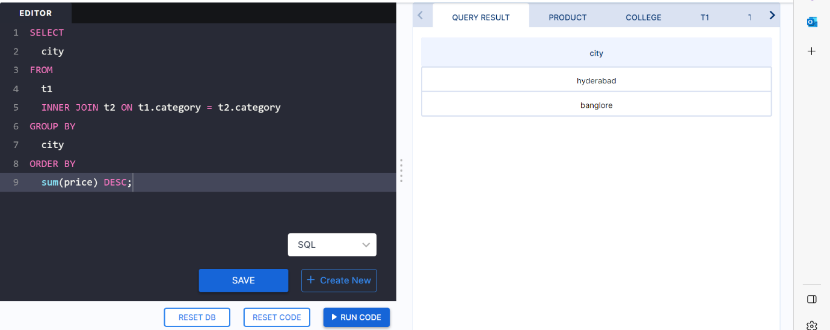

SELECT

city

FROM

t1

INNER JOIN t2 ON t1.category = t2.category

GROUP BY

city

ORDER BY

sum(price) DESC;